Jason Edwards
ID: 2545959
CSF2702 – Object oriented design
SIFFT IMPROVEMENT

Contents
1. Introduction and Description 2
1.1 The system 2
1.2 Use and function 2
1.3 Interactions with other systems 2
1.4 Purpose within the business and criticality 3
1.5 Intended end users 3
1.6 Requirements (focused scope) 3
2. Class Diagram of the System 0
3. Class Descriptions 0
3.1 Classes and responsibilities 0
3.2 Justification of each relationship 1
4. Suggestion for Improvement or Extension 3
4.1 The change 3
4.2 The existing problem and its likely cause 3
4.3 The classes responsible / requiring modification 4
4.4 How the change addresses the limitation — relevant factors 4
4.5 Evidence from the existing system 5
5. Design Patterns 6
5.1 What a design pattern is (framing) 6
5.1 Pattern 1 — Strategy 6
6. Evaluation 9
6.1 Design Pattern ? — the most effective/appropriate 9
6.2 Why not the other two info here 9
6.3 Conclusion / justification of the most effective 9
References 10

1. Introduction and Description

1.1 The system
SIFFT (Spark Ingestion Framework For Tables) is an in-house Python library used on the DVLA Data Platform. It gives a consistent way to bring data files into Apache Spark: reading files of different formats, checking data quality before it is stored, handling errors consistently, and writing the results to Delta tables [1].

1.2 Use and function
A scheduled Databricks job runs SIFFT daily in three steps — Pull (collect files), Ingest (load them into tables) and Cleanup. Two kinds of setting control each of the 50-plus daily feeds:
- How a file is read (its separator, whether it has a header, its columns)
- how its table is written (the target table, format and mode).

1.3 Interactions with other systems
SIFFT is called by Databricks jobs, reads files delivered by SFTP into cloud storage, and writes to Delta tables. Under the proposed improvement it would also read its settings from a separate configuration service. The service and SIFFT do not call each other directly; they share only the configuration the service manages and the job reads.

1.4 Purpose and criticality
These feeds fill tables used across DVLA for Drivers, Vehicles and Lookups data. The job runs daily and checks data before loading it, the correctness of its settings is business critical: a wrong separator or table name breaks that day's load for a whole area. Managing settings safely, without a redeploy, is therefore important.

1.5 Intended end users
The direct users are the DVLA Data Platform team, who run SIFFT jobs and author feed settings. Indirectly, everyone who uses the resulting tables depends on those settings being correct.

1.6 Requirements (focused scope)
SIFFT is a large library. This report focuses on the configuration and table-writing elements, as that is where the improvement and the design pattern apply.
SIFFT's file-reading internals, the CSVW constraint-validation engine and cloud file-management are out of scope. They are substantial subsystems with their own class hierarchies. Including would exceed the assignment requirements.

2. Class Diagram of the System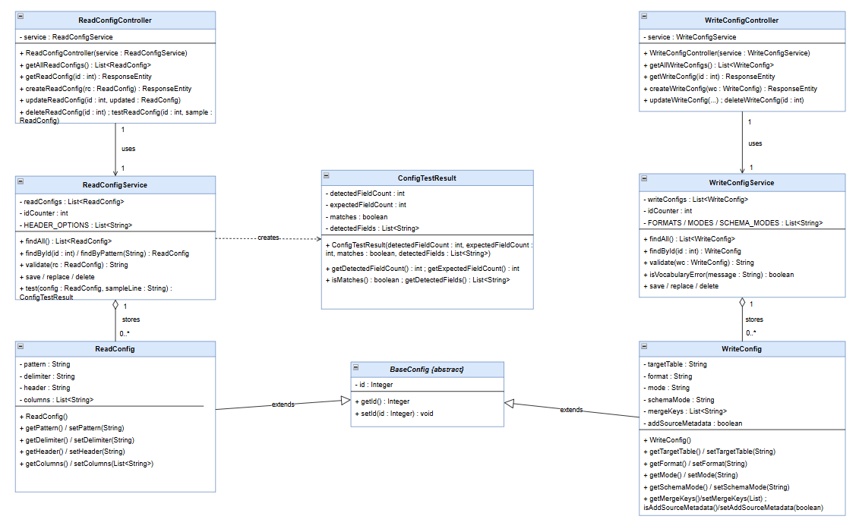

3. Class Descriptions

3.1 Classes and responsibilities
Each class of the system has a single clear job. Together they let a user create, change, delete and test the settings that control how files are brought into the data platform.

3.1.1 ReadConfigController
Entry point for read settings. It receives web requests, passes them to the service that does the work, and returns the response (including a "not found" message where needed). It holds no rules itself.

3.1.2 WriteConfigController
Entry point for write settings. It receives web requests, passes them to the service that does the work, and returns the response (including a "not found" message where needed). It holds no rules itself.

3.1.3 ReadConfigService
does the real work for read settings. It keeps the read settings and applies the rules (nothing required missing, a single-character separator, an allowed header value). It also runs the test feature: it splits a sample line using the stored separator and reports whether the number of fields matches.

3.1.4 WriteConfigService
Responsibilities include checking the table name, the format and other values, and the special merge rule. It also decides whether a rejected request was incomplete or simply used a disallowed value, so the right message is returned.

3.1.5 BaseConfig
BaseConfig is abstract. A shared "parent" class that holds an identifier (a unique reference number) common to both settings. Defining it once here removes repetition, as ReadConfig and WriteConfig inherit it.

3.1.6 ReadConfig
one read setting: filename pattern, separator, header choice and column names. It takes its identifier from BaseConfig and has simple ways to read and change each value.

3.1.7 WriteConfig
one write setting: target table, format, mode, structure-change option, merge keys and a source-information flag. It also takes its identifier from BaseConfig.

3.1.8 ConfigTestResult
a small result produced by the test feature: how many fields were found, how many were expected, whether they match, and the fields found.

3.2 Justification of each relationship
 | Class From | Class To | Multi-plicities | Relationship type | Why this type
1 | ReadConfigController | ReadConfigService | - | association | The controller always has, and relies on, the service to do the real work — a permanent working partnership, so a plain solid line pointing to the service.
2 | WriteConfigController | WriteConfigService | - | association | The same permanent partnership for write settings.
3 | ReadConfigService | ReadConfig | (1 -> 0..) | aggregation | The service holds a collection of read settings. They are things it groups together and looks after, so an open-diamond "has a" link, marked "zero or more" because it may hold any number.
4 | WriteConfigService | WriteConfig | (1 -> 0..) | aggregation | The same "holds a collection of" link for write settings.
5 | ReadConfig | BaseConfig | - | inheritance (generalisation) | A read setting is a kind of configuration, so it takes the shared identifier from the parent rather than defining its own. Shown with a hollow triangle pointing to the parent.
6 | WriteConfig | BaseConfig | - | inheritance (generalisation) | A write setting is also a kind of configuration, sharing the same identifier from the parent.
7 | ReadConfigService | ConfigTestResult |  | dependency | The service only creates a result slip for a moment while running the test, then hands it back; it does not keep one. A passing, one-off use like this is shown as a dashed "depends on" arrow rather than a permanent link.

4. Suggestion for Improvement or Extension

4.1 The change
The proposed change is to take SIFFT's ingestion settings out of code and manage them through a separate service, and to make the choice of write behaviour easy to extend. Currently the settings that tell SIFFT how to read each file and how to write each table are written directly into the Databricks job as a hard-coded “FILE_MAPPINGS” list and “TableWriteOptions” values. The improvement moves those settings out of the code so they can be created, changed and removed as data, and arranges the write step so that adding a new table format means adding a new class rather than editing an existing block of code.

4.2 The problem and its likely cause
Any settings change i.e. a new feed, a corrected separator, a new format, currently needs a code change and a redeploy. This is slow, needs developer access, and means a bad value is only found when the daily job fails in production. The cause is that the settings and the behaviour choice are both fixed into the job when it is built: the settings live as literals rather than as data read at run time, and the write behaviour is chosen with if/else branches, so adding a format means editing code that already works.

4.3 The classes responsible / requiring modification
Mapped onto the modelled system (Section 2–3):
Concern | Class(es) | Role in the change
Holds the externalised read/write settings | ReadConfig, WriteConfig (and their parent BaseConfig) | become data managed through the service rather than literals in code
Create and validate a config | WriteConfigService, ReadConfigService | gain the job of validating and storing config, and (for writes) delegating the behaviour
Choose write behaviour by “format” | FormatStrategy and its concrete strategies | replace the format “if”/”else” with interchangeable strategy classes (see Section 5)

The classes that “cause” the limitation are the ones that today hold the literal settings and branch on them. The classes that would be added or changed to remove it are the two services (which take on validation and, for writes, delegation) plus the proposed “FormatStrategy” classes introduced in the Design Patterns section.

4.4 How the change helps
Maintainability — onboarding a feed becomes one API call; decommissioning becomes a delete, instead of editing code and redeploying.
Extensibility — a new format is a new class that implements the interface; existing classes are untouched.
Testability — smaller, separated classes can each be checked on their own.
Coupling and cohesion — the change separates what to ingest (data) from how to ingest it (code), so each class has a single job.
Performance — roughly neutral (a lookup and a call instead of inline values), negligible against a once-a-day batch.

4.5 Evidence from the existing system
SIFFT is built to be extended: its workshop and documentation show custom handlers being registered and chosen at run time (for example, adding a handler for a new file type so the reader picks it up automatically) [2].
What is not externally managed today is the configuration that drives those handlers as it is located withing code. The improvement closes that gap, and the proof-of-concept service shows it is feasible and safe because it validates settings and rejects bad values when they are saved.

5. Design Patterns
5.1 Strategy pattern
Purpose
Strategy defines a family of related algorithms, places each in its own class behind a common interface, and makes them interchangeable so the one to use can be chosen at run time [2]. The object that needs the algorithm (the context) delegates to the chosen class rather than containing the algorithm itself.
The type of problem it addresses
Strategy addresses the situation where one behaviour varies among several alternatives and the set of alternatives is expected to grow. Handling that with branching logic (if format == "delta" ... else if ...) means the part that varies is tangled with the part that does not, and every new alternative requires editing code that already works. Replacing such conditional statements with interchangeable classes is a recognised refactoring towards the Strategy pattern [3].
Main structure
The pattern has three roles: a *strategy interface* declaring the varying operation; several *concrete strategies* that each implement it differently; and a *context* that holds a reference to a strategy and delegates the work to it. The context depends only on the interface, so concrete strategies can be swapped without changing it.

How it could be applied to the improvement
In the improved system, how a table is written varies by its format (delta, parquet, orc). A FormatStrategy interface would declare one operation, write(...). Each format would be its own concrete class — DeltaStrategy, ParquetStrategy, OrcStrategy — implementing that operation in its own way. The context, WriteConfigService, would hold a FormatStrategy and delegate the write to it. Because the externalised configuration stores the format as a value, that stored value selects which strategy the context uses, and adding a new format means adding a new class rather than editing the existing ones. The low-level class diagram for this is shown in Figure 2.

*Figure 2 — Strategy pattern applied to the write-format behaviour (proposed design).*
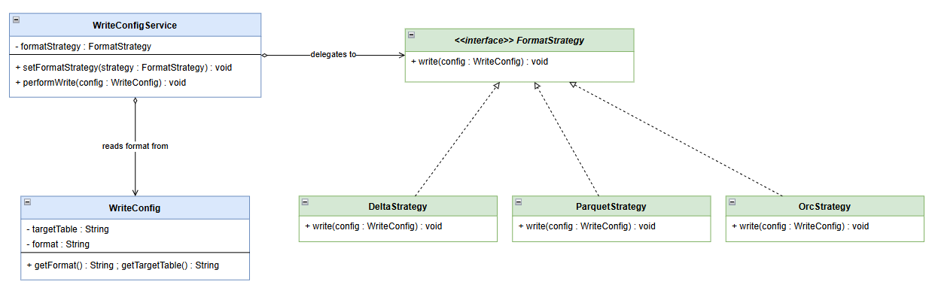

Interface, not inheritance
FormatStrategy is deliberately an interface rather than a shared parent class. The module's guidance is to program to an interface and to favour composition over inheritance: here the formats share a *capability* (how to write), not state, so an interface the context composes is the right tool. Inheritance is used elsewhere, for shared *state* — BaseConfig in Section 3 — which shows each mechanism applied to the job it suits.
**Advantages.**
Each write behaviour is encapsulated and can be reused on its own; the behaviour can be changed at run time by swapping the strategy; the context depends on an interface, not on concrete formats, which lowers coupling; and a new format is a new class that leaves existing classes untouched.
**Disadvantages.**
It introduces more classes than a single block of branching (one per behaviour), which is the recognised cost of the pattern [1]; the context, or the code around it, still has to select the correct strategy; and there is a small run-time cost in delegating to another object rather than running inline code.
**Why it is appropriate.**
The improvement is fundamentally about choosing write behaviour from stored configuration, which is exactly the problem Strategy solves. It also fits how the existing system is already built: SIFFT models its write formats as a set of interchangeable handler classes behind a common type, selected at run time (Section 4.5) [3]. Applying Strategy in the configuration service is therefore a faithful restatement of a design the system already relies on, not a contrived fit.

5.3 Pattern 2 — tbc
5.4 Pattern 3 — tbc

6. Evaluation

6.1 Design Pattern ? — the most effective/appropriate

6.2 Why not the other two info here

6.3 Conclusion / justification of the most effective

References
[1] [SIFFT] DVLA, Spark Ingestion Framework for Tables (SIFFT), GitHub repository,
“https://github.com/dvla/sifft”

[2] Gamma, E., Helm, R., Johnson, R. and Vlissides, J. (1994) Design Patterns: Elements of Reusable Object-Oriented Software. Reading, MA: Addison-Wesley.
[3] Christopoulou, A., Giakoumakis, E.A., Zafeiris, V.E. and Soukara, V. (2012) 'Automated refactoring to the Strategy design pattern', Information and Software Technology, 54(9),pp. 1202–1214.

